Hi..

A brief manual for customizing the site:

- Open „page2.fla“
- Set timeline to frame „174“. Now you should see these picture

- Menu items (about, product, service, contact)
- Content of the menu items

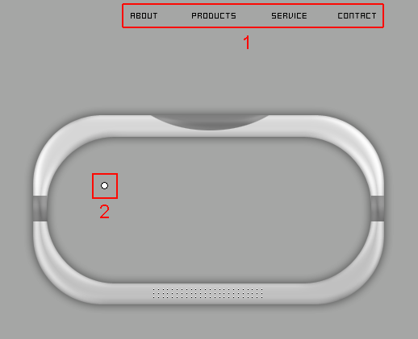

Doubleclick on the “menu items” and “company name” to change it (choose the arrow-tool)

For changing the menu items, doubleclick on the “circle”.
Now you should see this picture.

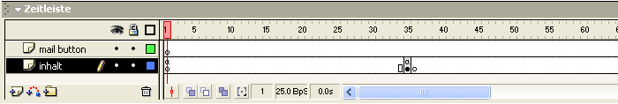

Inhalte der Menupunkte:

Frame „35“ = ABOUT
Frame „70“ = PRODUCT
Frame „105“ = SERVICE
Frame „139“ = CONTACT
Example:

1. For changing „ABOUT“, highlight Frame „35“, Now the textfield on the stage should be
framed in blue.

2. Doubleclick on the textfield, now you can enter your own texts.
On frame “139”, there is an email button. You can change the mail address in “actions”

on (release) {
getURL("mailto:akreis@gmx.net");
}
If you like to use the same font, just copy “swfit.ttf“ in your windows fonts folder.

If you have any questions, feel free to contact me akreis@gmx.net

Have a lot of fun :)
Aaron

www.NetPerformance.de v2.0

