Album Toolkit
Nosque Workshop
Album Toolkit is an useful album program. Here, Album Toolkit provides two main windows for browsing picture files and printing picture files (see note 1).

Introduction

Album Viewer
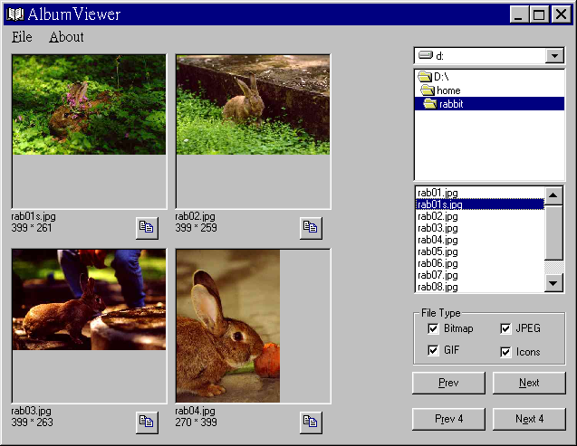
As you start Album Toolkit, the ‘Album Viewer’ may appear on the screen( if Album Toolkit start with the ‘Album Printer’ windows, you may click the menu item ‘Edit | Album Viewer’ to start the ‘Album Viewer’ ). Under ‘Album Viewer’, you may browse the picture files and look 4 pictures of them at once.

Album Printer
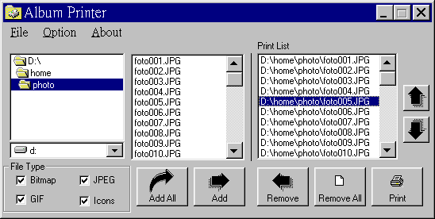
As you start Album Toolkit, the ‘Album Printer’ may appear on the screen( if Album Toolkit start with the ‘Album Viewer’ windows, you may click the menu item ‘Edit | Album Printer’ to start the ‘Album Printer’ ). Under ‘Album Printer’, you may choose the picture files which you wish to print out, and setup the layout of the printing.

Note 1. Album Toolkit support Bitmap file, JPEG file, GIF file, and Icon file.

Function

Album Viewer

File Type
Select the type of picture files.

Prev
Start with the previous file.

Next
Start with the next file.

Prev 4
Start with the previous 4th file.

Next 4
Start with the previous 4th file.
Add the file to ‘Album Printer’ print list.

File | Album Printer
Start ‘Album Printer’.

File | Close
Closet this window.

File | Exit
End the Alubm Toolkit.

Album Printer

File Type
Select the type of picture files.

Add All
Add all files into print list.

Add
Add the selected file into print list.

Remove
Remove the selected file in the print list.

Remove All
Remove all files in the print list

Print
Print the picture file in the print list.
Set the order of the selected file..

File | Album Viewer
Start ‘Album Viewer’.

File | Print Setup
Setup the printer.

File | Preview
Print preview.

Option | Scale
Select the scale unit used in the program.

Option | Center
Set all picture printed at the center of the paper.

Option | Font
Set the font of the label.

Option | Print File Name
Print file name as label.

Option | Print File Path
Print file name and file path as label.

Option | Label Above Picture
Set the label position.

Option | Label Below Picture
Set the label position.

Option | Print Size
Set the picture printing size.

Option | Header
Set the paper’s header.

Option | Footer
Set the paper’s footer.

Registration
To register Album Toolkit, you may click the menu item ‘About’ to start the About dialog box.
Press the button Register to get into the Register dialog box, and enter the registration information into each textbox.
Press Ok to finish registration.
Register you own Album Toolkit at http://www.shareit.com/programs/101297.htm
And you will receive your registration key via email.

Order Form
Album Toolkit Registration
----------------------------------

Registration fee: $25

If you would like to register Album Toolkit, you can do the registration online on
the Internet at http://www.shareit.com/programs/101297.htm. Alternatively, you can
go to http://www.shareit.com and enter the program number there: 101297.

If you do not have access to the Internet, you can register via phone, fax or
postal mail. Please print out the following form, and fax or mail it to:

ShareIt! - Reimold&Schumann Internet Services
Habsburgerring 3
50674 Koeln
Germany

Phone: +49-221-2407279
Fax: +49-221-2407278
E-Mail: register@shareit.com

US customers may also order by calling 1-800-903-4152 (orders only please!). US check and
cash orders can be sent to our US office at

ShareIt! Inc.
P.O. Box 97841
Pittsburgh, PA 15227-0241
USA

Registration form for Album Toolkit

Program No.: 101297

Last name: ___________________________________

First name: ____________________________________

Company: ____________________________________

Street and #: ______________________________________

City, State, postal code: ________________________________

Country: _______________________________________

Phone: _____________________________________

Fax: ________________________________________

E-Mail: ______________________________________
(E-Mail address is vary important for receiving the registration key)

How would you like to pay the registration fee of US$25:

____credit card ____wire transfer ____EuroCheque ____cash

Credit card information (if applicable)

Credit card: ___Visa ___Eurocard/Mastercard ___American Express ___Diners Club

Card holder: ________________________________

Card No.: ___________________________________

Date of Expiration : ___________________________________

Date / Signature ___________________________

------------------------------------------------------------------------------

