The Microsoft Office Spreadsheet
Discover better ways to analyze data and find solutions using Excel 2000 and its streamlined spreadsheet creation tools, enhanced analysis tools, and powerful Web integration. Whether you are an expert or a novice, Excel will help you work more efficiently, turning your data into answers you can count on.

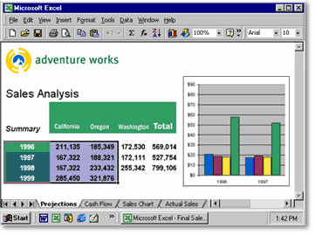

Excel 2000—More Than Numbers
Excel 2000 provides comprehensive tools to help you create, analyze, and share spreadsheets. Create rich spreadsheets more easily than ever using enhanced formatting features. Analyze your data with charts, PivotTable® dynamic views, and graphs. And post your results to the Web for universal viewing and collaboration.

Learn more about these topics in the Excel 2000 brochure:
- Manage and Share Information
- Easily Access and Analyze Data
- Streamline the Way You Work
- System Requirements
Manage and Share Information
As part of Office 2000, Excel adopts HTML as its companion file format, so you can easily share data-rich spreadsheets in a Web browser—letting even those who don't have Excel view your data. Further Office integration introduces seamless e-mail and powerful collaboration tools that help your team work together more effectively.

E-mail Your Data Without Leaving Excel
Integration with the rest of Office 2000 makes it easy to share your work. Just click the new Office E-mail button on your toolbar to open the Microsoft Outlook® Mail header, then e-mail your document as is, right from Excel. Your document is sent in HTML format, which allows any recipient to view it. Recipients with Excel can open your spreadsheet in the application for further analysis.

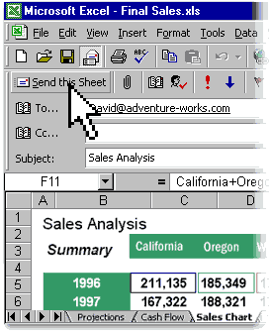

Share Your Data Online
Use the Office 2000 Save As Web Page feature to save your work in HTML file format. This allows anyone with a Web browser to view your document with the same rich quality as you created it. You can also edit Web pages created in Excel using Office Web Editing—simply "round-trip" your document back into Excel, where you can update it with full program functionality.

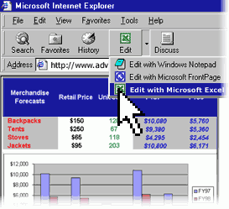

Collaborate with Others
Get your team's feedback on your data through Web Discussions. Multiple users can insert comments within Office documents and HTML files that can be viewed from a Web browser. Now you can have instant access to your teammates' remarks as soon as they're posted.

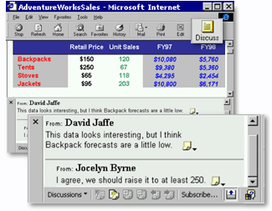

Easily track team efforts by subscribing to any Office document, folder, or HTML page on your Web server. Determine how frequently you want to be notified of changes to those files, and Web Subscriptions will automatically notify you of changes through e-mail.
Easily Access and Analyze Data
Excel 2000 makes it easier to access vital business information using your organization's intranet, and then analyze that information to help you make informed and timely business decisions.

Work Collectively with Web Components
Excel and Office 2000 bring you the power of Office Web Components, providing Web viewers the ability to manipulate spreadsheet, chart, and PivotTable data from within their browser for on-the-spot data analysis. Simply click the "Add Interactivity" button when you Save As Web Page.

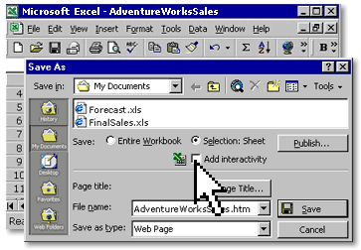

Use the Increased Flexibility of PivotTables
Add and remove data fields directly on your worksheet to view data exactly the way you want to—it's easy with the improved PivotTable interface. And use the new PivotTable AutoFormat feature to easily create professional-quality reports.

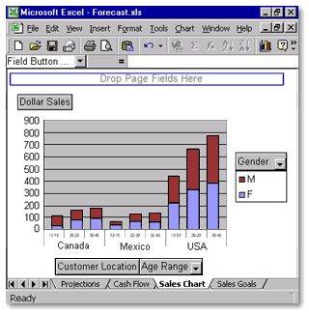

New PivotChart™ views offer powerful, visual representations of your data that can easily be manipulated for further analysis. Because PivotChart and PivotTable views are linked, they are updated in tandem as you change or move fields.

Feed Live Data from the Web into Your Formulas or Charts
Set up Web Queries to import real-time data—such as stock quotes and currency exchange rates—from the Web into your spreadsheet or database. Excel 2000 walks you through the steps of creating new Web queries, and allows for automatic refreshes.

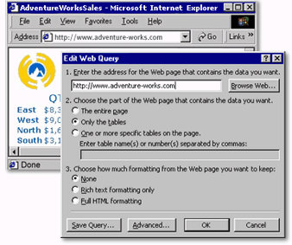

Streamline the Way You Work
The intelligent features of Excel 2000 not only help you work faster, but also help you create, edit, and format powerful spreadsheets and reports with less effort than ever.

Add New Data Without Reformatting Cells
Add new columns and rows without having to manually apply formatting and formulas. The new List AutoFill feature intelligently applies existing column or row formulas and formatting to new fields.

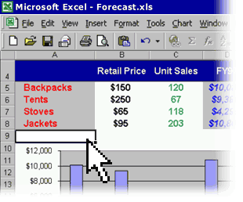

Format Cells Faster Than Ever
See how your changes look without having to deselect highlighted cells. The new See-Through View lightly shades selected cells rather than reversing them out, so you can make formatting changes and immediately see if you've achieved your desired results.

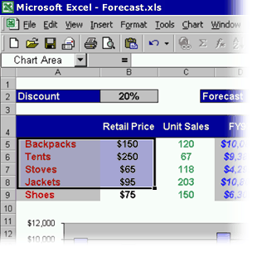

Create High-Impact Reports with Custom Cells
Rotate and indent text within a cell, even merge cells, without tricky formatting. Customizable cells make dynamic spreadsheet presentation a breeze.

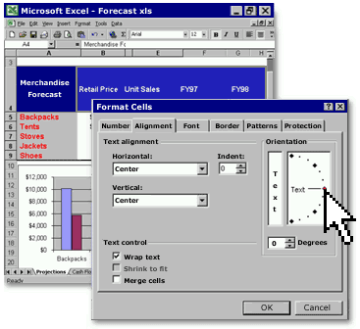

System Requirements

Get more from Excel as part of Office 2000.
Below you'll find the system requirements for Excel 2000. First you can see which applications are included in each Office Suite.

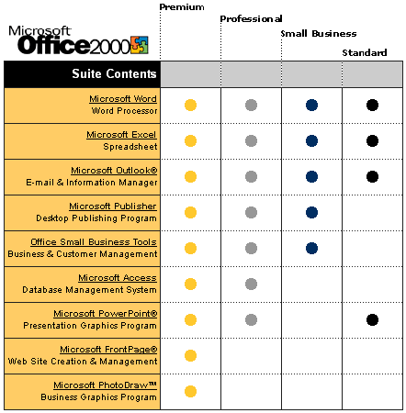

To use Microsoft Excel 2000, you need:

- PC with a Pentium 75 MHz or higher processor
- Microsoft Windows® 95 or later operating system, or Microsoft Windows NT® Workstation
operating system version 4.0 Service Pack 3 or later
- For Windows 95 or Windows 98:
16 MB of RAM for the operating system, plus an additional 4 MB of RAM for Excel
- For Windows NT Workstation:
- 32 MB of RAM for the operating system, plus an additional 4 MB of RAM for Excel
- 146 MB of available hard-disk space (Number indicates typical installation; your hard-disk
usage will vary depending on configuration. Choices made during custom installation may require more or less hard-disk space.)
- CD-ROM drive
- VGA or higher-resolution monitor; Super VGA recommended
- Microsoft Mouse, Microsoft IntelliMouse®, or compatible pointing device

Additional items or services required to use certain features:

- 9600 baud modem; 14,400 or higher-baud modem recommended
- Multimedia computer required to access sound and other multimedia effects
- Microsoft Outlook 2000 or Microsoft Outlook Express 5.0 or later required to run Office E-mail
- 8 MB of additional memory required to run Office E-mail
- Some Internet functionality may require Internet access and payment of a separate fee to a
service provider

Pricing:
For pricing and upgrading eligibility information on Microsoft Excel 2000 please visit the Office Web site at http://www.microsoft.com/office

© 1999 Microsoft Corporation. All rights reserved. This data sheet is for informational purposes only. MICROSOFT MAKES NO WARRANTIES, EXPRESS OR IMPLIED, IN THIS SUMMARY. The example companies, organizations, products, people, and events depicted herein are fictitious. No association with any real company, organization, product, person, or event is intended or should be inferred.

Microsoft, FrontPage, IntelliMouse, the Microsoft Internet Explorer logo, the Office logo, Outlook, PhotoDraw, PivotChart, PivotTable, PowerPoint, Windows, the Windows logo, Windows NT, and the Windows Start logo are either registered trademarks or trademarks of Microsoft Corporation in the United States and/or other countries. Other product and company names mentioned herein may be the trademarks of their respective owners.

Microsoft Corporation • One Microsoft Way • Redmond, WA 98052-6399 • USA

Microsoft Canada Inc. • 320 Matheson Blvd. West • Mississauga, ON L5R 3R1 • Canada

0599 Part No. 098-82229

