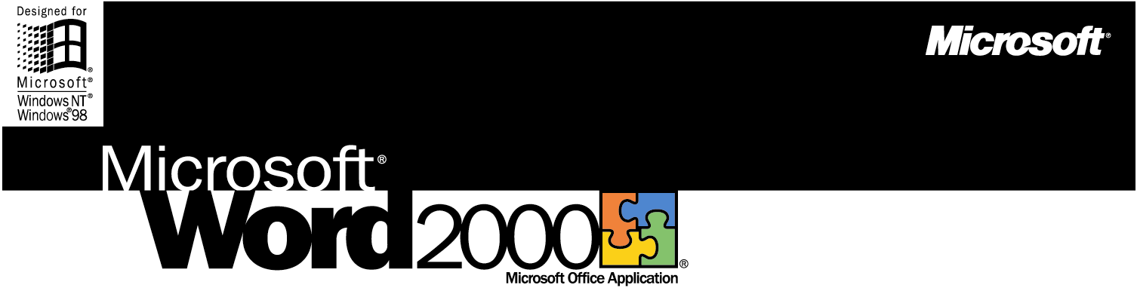

The Microsoft Office Word Processor
Microsoft Word 2000 gives you the tools to more easily create professional-quality documents and share information—in print, e-mail, and on the Web.

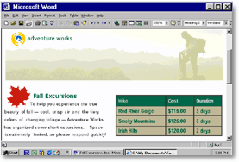

The World's Best-selling Word Processor for Windows®
Is Now Better Than Ever
Word 2000 combines streamlined document creation with powerful Web functionality so you can work more efficiently and communicate your ideas more effectively. Advanced integration with the rest of Office 2000 enables you to easily include text, data, and graphics from other Office applications to create high-impact documents.

Learn more about these topics in the Word 2000 brochure:
- Streamline the Way You Work
- Manage and Share Information
- System Requirements
Streamline the Way You Work
Word 2000 helps you make the most of your time. With intelligent new formatting features, it's faster and easier to create highly effective print and Web-based documents.

Quickly Format Your Document the Way You Want It
Select the perfect font the first time with the new drop-down WYSIWYG (what you see is what you get) font menu, which gives you a preview of font styles before you choose them.

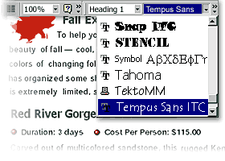

Click anywhere on your page and start typing. New Click and Type makes it a snap to center-align text, indent paragraphs, and more—no more having to press TAB and ENTER to get where you want to start typing.

Easily Cut and Paste from Multiple Documents
No more jumping back and forth to cut and paste between different documents. Office 2000 Collect and Paste allows you to store up to 12 pieces of information from different documents on the clipboard, and then insert them—one at a time or all at once—into your Word document.

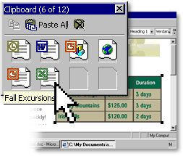

Draw and Format Tables Quickly
Take advantage of improved table flexibility to automatically wrap text around your tables, and create documents that contain floating tables.

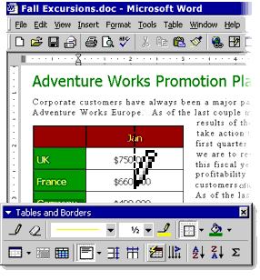

Create tables exactly the way you want them to appear. The updated Table Tool makes it easier than ever to draw and edit tables. Draw your table one cell at a time, erase several lines at once, and even split cells diagonally.

Create High-Impact Documents with a Click of Your Mouse
Choose from hundreds of new clip-art images, and find more on the Office Web site. Insert or simply drag images into your document.

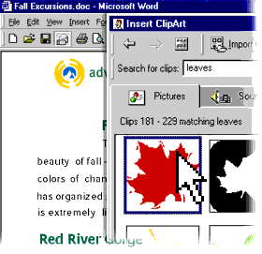

Select from new professional templates such as fax cover sheets, resumes, and Web pages to easily create documents that look great.

Break Language Barriers with Intelligent Multilingual Support
Easily create multilingual documents. Word automatically determines what language* a user is typing and applies the correct proofing tools, including AutoCorrect, Spelling, and Grammar.

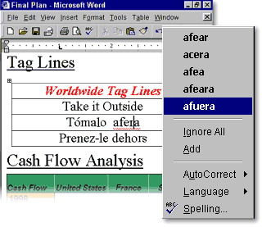

*Works with English, French, and Spanish.

Manage and Share Information
Improve your productivity through streamlined communication and new avenues for collaboration. As part of Office 2000, Word allows you to easily share and manage information through e-mail, print, and the Web using tools you're already familiar with.

Use Office E-mail to Send Documents Instantly
E-mail your document without ever leaving Word. Just click to open the new Office E-mail header in Word and send your document as an e-mail message that retains your original formatting.

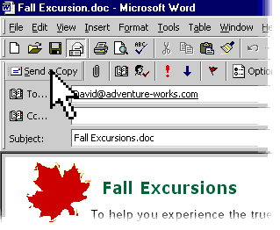

Easily Share High-fidelity Documents Online
As the companion file format for Office 2000, HTML makes it easy to share information with anyone. Use the Save As Web Page (HTML) feature to create a document that anyone with a browser can view with the same high fidelity as it has in Word.

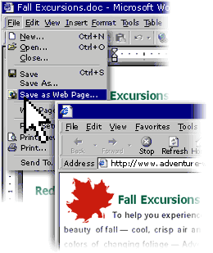

Edit Web pages created in Word using Office Web Editing—simply "round-trip" your document back into Word, where you can update it with full program functionality.

Create Professional-Quality Web Pages
As part of Office 2000, Word shares Web page Themes with the FrontPage® 2000 Web site creation and management tool. Use a Theme template to create new Web pages or apply a Theme to an existing Web page. Choose from more than 30 predesigned Themes that include varying graphical elements such as backgrounds, bullets, text formatting, and color options.

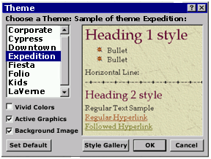

Improve Collaboration and Manage Information Easily
Turn the Web into a collaboration tool with Web Discussions. Insert discussion comments within a document, or open a window for general discussion at the bottom of a page. Use the Discussions toolbar to add comments, navigate through existing comments, view or hide the discussion window, or subscribe to a document.

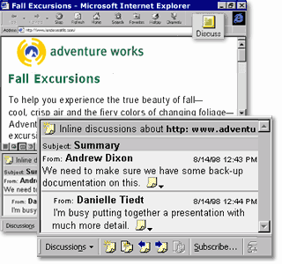

Web Subscriptions allow you to easily track collaborative efforts. Subscribe to be notified of changes made to any Office 2000 or HTML document on your Web server. You determine the conditions and frequency of updates, which are automatically sent to you by e-mail.

Share Information More Effectively with Improved Hyperlinks
Insert hyperlinks into your documents more easily with the improved hyperlink interface. Quickly create links to other documents, Web pages, graphics, and pictures—and even customize how text is displayed in your links. Word automatically checks all links and corrects those that have moved or aren't working.

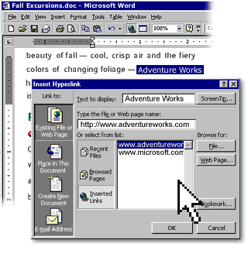
System Requirements

Get more from Word as part of Office 2000.
Below you'll find the system requirements for Word 2000. First you can see which applications are included in each Office Suite.

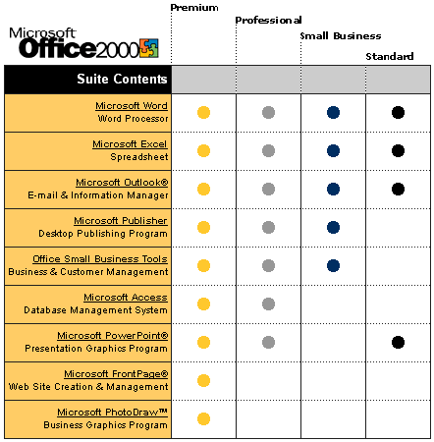
To use Microsoft Word 2000, you need:

- PC with a Pentium 75 MHz or higher processor
- Microsoft Windows® 95 or later operating system, or Microsoft Windows NT® Workstation operating system version 4.0 Service Pack 3 or later
- For Windows 95 or Windows 98:
- 16 MB of RAM for the operating system, plus an additional 4 MB of RAM for Word
- For Windows NT Workstation:
- 32 MB of RAM for the operating system, plus an additional 4 MB of RAM for Word
- 147 MB of available hard-disk space (Number indicates typical installation; your hard-disk usage will vary depending on configuration. Choices made during custom installation may require more or less hard-disk space.)
- CD-ROM drive
- VGA or higher-resolution monitor; Super VGA recommended
- Microsoft Mouse, Microsoft IntelliMouse®, or compatible pointing device

Additional items or services required to use certain features:

- 9600 baud modem; 14,400 or higher-baud modem recommended
- Multimedia computer required to access sound and other multimedia effects
- Microsoft Outlook 2000 or Microsoft Outlook Express 5.0 or later required to run Office E-mail
- 8 MB of additional memory required to run Office E-mail
- Some Internet functionality may require Internet access and payment of a separate fee to a service provider

Pricing:
For pricing and upgrading eligibility information on Microsoft Word 2000 please visit the Office Web site at http://www.microsoft.com/office

© 1999 Microsoft Corporation. All rights reserved. This data sheet is for informational purposes only. MICROSOFT MAKES NO WARRANTIES, EXPRESS OR IMPLIED, IN THIS SUMMARY. The example companies, organizations, products, people, and events depicted herein are fictitious. No association with any real company, organization, product, person, or event is intended or should be inferred.

Microsoft, FrontPage, IntelliMouse, the Microsoft Internet Explorer logo, the Office logo, Outlook, PhotoDraw, PowerPoint, Windows, the Windows logo, Windows NT, and the Windows Start logo are either registered trademarks or trademarks of Microsoft Corporation in the United States and/or other countries. Other product and company names mentioned herein may be the trademarks of their respective owners.

Microsoft Corporation • One Microsoft Way • Redmond, WA 98052-6399 • USA

Microsoft Canada Inc. • 320 Matheson Blvd. West • Mississauga, ON L5R 3R1 • Canada

0599 Part No. 098-82337

